Art Integration Lesson Plan Template
LTC 4240: Art for Children

Lesson Title & Big Idea*: Family |  | Grade Level*: 5
Lesson Overview/Summary*:  Learn about the artist Romare Bearden and how his artwork reflects the theme of family. |  | Class Periods Required:  (please circle)  1 2 3
Key Concepts (3-4):  - Visual Art  - Collage  - Reflecting the big idea of family in one’s art pieces  - Knowledge about the artist Romare Bearden  - Analyzing and generating ideas about what an artist is saying or showing through their art (VTS)  - Literacy  - How to analyze the stories that teachers read to their students  - To think critically about what the teachers read to their students and how the book reflects the big idea of family  - Social Studies  - The history and background of the artist Romare Bearden  - United States Historical Events/ Time Periods:  - Pre-Reconstruction slavery  - The Great Migration  - The Harlem Renaissance | Essential Questions (3-4)*:  - What is family?  - Why is family significant?  - In what ways might art reflect family?
Lesson Objectives: (Excellent resource at http://www.teachervision.fen.com/curriculum-planning/new-teacher/48345.html?for_printing=1&detoured=1):
- Students will learn about the big idea family and how that big idea can be reflected in their art.
- Students will be able to understand the time period that Romare Bearden lived in and understand what The Great Migration and Harlem Renaissance periods were within the United States.
- Students will be able to represent their family in their art through collage and will be able to see the big idea of family reflected in the artworks that they see from other artists.
Grade Level Expectations (GLEs) (3-4) (http://dese.mo.gov/divimprove/curriculum/GLE/)  - (Social Studies) SS3 1.6, 3.1 – Identify political, economical and social causes and consequences of the Civil War and Reconstruction  - (Social Studies) SS5 1.10 – Identify human characteristics, such as people’s education, language, diversity, economies, religions, settlement patterns, ethnic background and  - (Visual Art) VA1, FA1, 3.C. – Create an original artwork that communicates ideas about the following themes:  • United States  • Patriotism  • World  • Time (e.g., past, present, future)  - (Literacy) CA 2, 3, 1.5, 1.6, 3.5 – *During reading, utilize strategies to  a. determine meaning of unknown words  b. self-monitor comprehension  c. question the text  d. infer  e. visualize  f. paraphrase  g. summarize | Identify & define common vocabulary that connect the art form with the other identified content areas:  - Family – n. 1. a group consisting of parents and children living together in a household.  • a group of objects united by a significant shared characteristic.  • a person or people related to one and so to be treated with a special loyalty or intimacy: I could not turn him away, for he was family.  - Collage – n. a piece of art made by sticking various different materials such as photographs and pieces of paper or fabric onto a backing (Bearden used collage as a medium for some of his artwork including “"Watching the Good Trains Go By," 1964).  - Harlem Renaissance – n. a literary movement in the 1920s that centered on Harlem and was an early manifestation of black consciousness in the US The movement included writers such as Langston Hughes and Zora Neale Hurston (Romare Bearden).  - The Great Migration – n. The original Great Migration (African American) from the southern United States to the northern United States (1910–1930).
Content Areas Integrated*:  1. Visual Art (Inspiration Artist: Romare Bearden)  2. Literacy  3. Social Studies | Lesson Activities & Procedure(s) (please be very specific):  1. Anticipatory Set (Gaining Attention): I would start out by having my students come sit on the carpet on the floor in front of the SmartBoard showing my students an image of a collage that Romare Bearden created called "Watching the Good Trains Go By," 1964, and VTS it for 10 min.  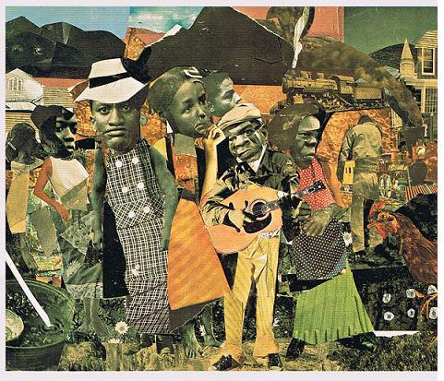  2. I will then paraphrase the thoughts that everyone had about the image that everyone had through the VTS activity and go into the rest of the PowerPoint presentation introducing the artist of the piece as Romare Bearden and the artist that we will be learning about.  3. I will then read aloud the book My Hands Sing the Blues: Romare Bearden's Childhood Journey by  4. After the book I will open the floor for post-reading questions  - What stood out to you in the reading?  - What did we learn about Romare Bearden?  - What did we learn about our big idea family through this book?  - What did we learn about Romare Bearden’s family and background?  5. I will then send everyone back to their seats, and we will go over more information about Romare Bearden through my PowerPoint.  6. I will state the facts about Romare Bearden and ask my students questions that they should be able to answer about him after we read the book together.  - He was an artist.  - When he was a boy he lived in North Carolina  - What do we know about him and his family?  - They were of African, Cherokee and Italian descent.  - His ancestors were slaves in the South (significance of train and underground railroad).  - Where did he and his family move to?  - Harlem, New York City  7. I will then go into what the Great Migration was that Romare Bearden and his family was a part of between (1910-1930).  - The movement of African- Americans moving from the oppressive laws developing in the South to a new life in the North.  - Harlem, New York City being one of the cities people moved to.  8. I will then show a video from the History Channel website about The Great Migration http://www.history.com/topics/great-migration/videos#the-harlem-renaissance  9. Then I will go into talking about the Harlem Renaissance and what that was and how that came about because of The Great Migration.  - Many of the most artistic, creative, and intellectuals African Americans found a home in Harlem, New York City making it a main power source for the African American culture and society in the 1920’s.  - The movement faded away in the early 1930’s when the The Great Depression hit the United States.  - YouTube video about the Harlem Renaissance: http://www.history.com/topics/great-migration/videos#the-harlem-renaissance  10. I will then show a picture and talk about the artist Romare Bearden.  - He was an artist and writer influenced by the Harlem Renaissance.  - Graduated with a degree from University of New York.  - Most known for his collages.  - Death: March 12, 1988  11. I will then show the picture that we VTSed again and some other art pieces of his.  12. I will go back one more time to the art piece that we VTSed called "Watching the Good Trains Go By," 1964 and ask the student now to tell me what they see in this collage now that they didn’t see before since they now know more about Bearden’s background and family and about the time period that he was a part of.  - How does this collage represent Bearden’s family and past?  - How does this collage represent himself and where he came from?  13. Art activity: I now will introduce the art activity that we will be doing that will incorporate the big idea of family and reflect the art of Romare Bearden and his work with the collage medium. We will be reflecting Bearden’s art piece "Watching the Good Trains Go By," 1964 that we have VTSed and talked about extensively throughout the lesson by using the heads of the pictures of our own family, magazine clippings, scrapbook paper, wallpaper, colored paper, fabrics etc. and glue sticks that I will have in available to the students. I will encourage them to use in the background images that they find that represent their family and things that are special to them.  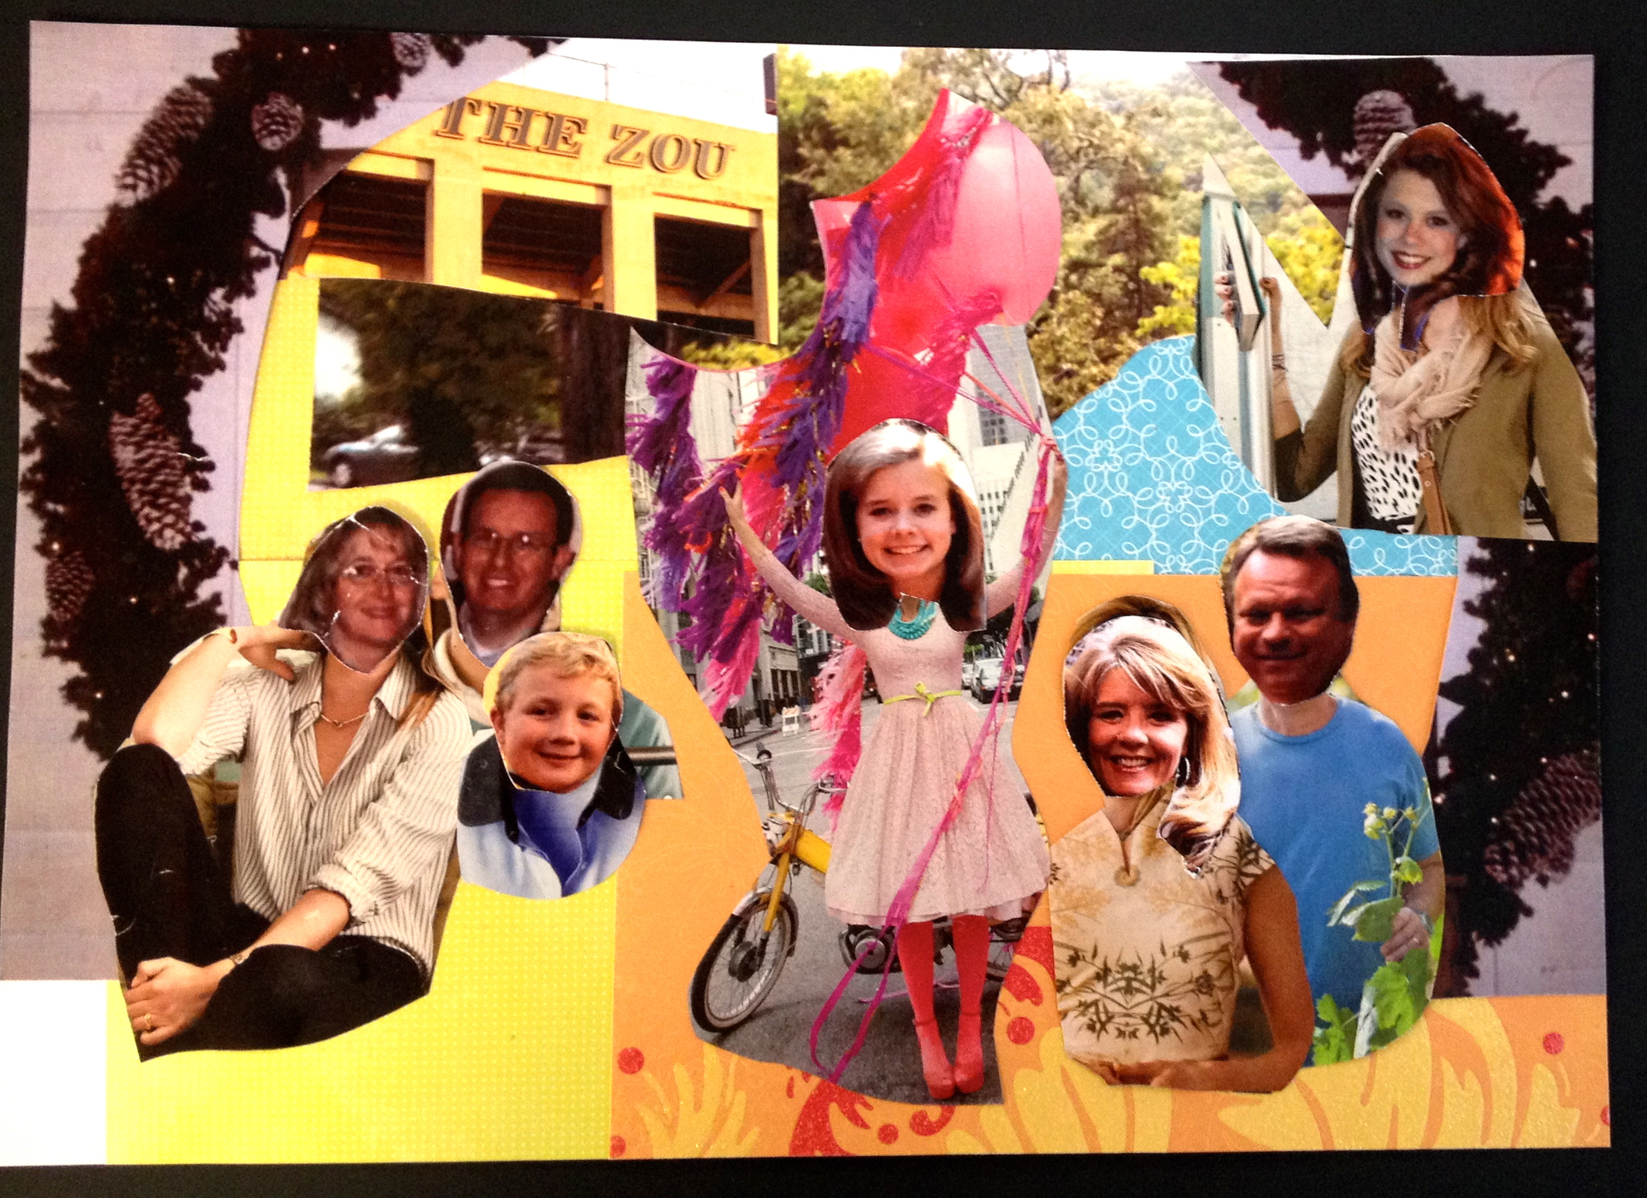  14. Before they get to work on their own piece I will show the kids the collage techniques of Matisse, through gathering them around me at a table so that I can show them an example piece that I will create that I pre-made. I will show them the clippings that I already have and how I cut out the heads of my family members to put onto the pieces of my collage. I will show them how to arrange them first so that they can see what works the best on their paper before they glue down the final piece. I will tell them to only glue around the edges and put the lid back onto the glue stick when they are done.  15. I will then ask everyone to return to their seats and tell them to use the remainder of the class period to work on their collage and that we will finish it in the next class period.  16. After the art projects are all done during the next class period, I will ask each one of them to share their collages with the class and ask them to explain why they chose the images, paper, and colors that they did and how their artwork represents their own family reflecting back on the big idea of the unit “family.”
Anticipatory Set (Gaining Attention)*:  I would start out by showing my students a collage that Romare Bearden created called "Watching the Good Trains Go By," 1964, and VTS it for 10 min and then go onto the remainder of the lesson about Romare Bearden's background and go over how her artwork reflects the big idea of family. | Closure (Reflecting Anticipatory Set):  After the art projects (collages) are all done during the next class period, I will ask each one of them to share their collages with the class and ask them to explain why they chose the images, paper, and colors that they did and how their artwork represents their own family reflecting back on the big idea of the unit “family.”
Formative Assessment strategy:  I will be asking the students questions making sure they are engaged and understand what is being taught. There are a ton of questions concerning how the big idea of family can be seen in art and how it connects to that big idea. I will be doing thumbs up if you understand and thumbs down if they don’t. I will be checking with the students as they work on their collage and paper and make sure they are doing ok and understand the task. | Summative Assessment strategy*:  Just like Romare Bearden creates collages reflecting family and background we are going to create our own collages that represent our own families using your own family photos other materials! Reflect on Romare Bearden's artwork and think how you can incorporate how he reflects family in his collages in your own! After you are finished, please write on a separate sheet of notebook paper what your artwork is about and why you chose to create your piece in the way that you did and how your artwork reflects the big idea of "family." After everyone is done with their collage and writing piece we will have everyone share their collage with the rest of class and tell us about how it reflects the big idea "family."
What student prior knowledge will this lesson require/draw upon?
The students will before this lesson have an understanding of the racial unrest that was present in our history pre-Civil War and post-Reconstruction. They will understand how the VTS routine works and how that is run.

How will you engage students in imagining, exploring, and/or experimenting in this lesson?
During the VTS time, they are able to imagine why the artist did what he did in the artwork and they can explore the possibilities of why the artist made the decisions that he did in his piece. The students will have full reign to explore the pieces of papers that I have for them to make their collage and they can be as creative and imaginative as they want. They can experiment with the placement of the papers that they use like Matisse is with his collages and they can just do their artwork however they want to as long as it reflects the big idea of family.
How will this lesson allow for/encourage students to solve problems in divergent ways?
It really makes the students think about how they can create the idea of family in a collage in a different way that is more creative than just having a collage of pictures that they have of their family. They have to put more elements in it that express their experiences and think critically about what is special and important to their family whether it is something unique or not.
How will you engage students in routinely reflecting on their learning?
I will continue to talk about the big idea of family and through the life of Romare Bearden and his background and history I will show the students how they can reflect the big idea of family in their own artwork. We will keep reflecting on the big idea of family and how Romare Bearden reflected family in his pieces and how the students can do the same in their own work.
How will you adapt the various aspects of the lesson to differently-abeled students?
I will have pre-cut out pieces and images for their collage so that it is not as overwhelming for them to look through all the pieces of paper that I have available for my class to use to create their collage. I will during their activity time check with them and make sure they understand what we talked about in the lesson and answer any questions or concerns that they have about it.
What opportunities/activities will students be given to revise and improve their understandings and their work?
I will show them how to do their collage initially like Matisse and so they have room to improve it before they glue it down, so the composition can be the best that it can be. I will also read their writing on their artwork and talk about it with them at a later date. I will talk about their thoughts about it and how they can make their paper about it better.
What opportunities/activities will you provide for students to share their learning in this lesson?
The students will be able to share their ideas during the VTS time that we will have at the beginning of class. They will be able to answer questions that I pose during the lesson and share their ideas then as well. At the end of the less they will also have the opportunity to share their collages with the class once they are finished with them, and share with the class how their own collages reflect their family and why they chose the images, colors, and pictures that they did.
Lesson Resources/References (please be very specific by providing links, authors, titles, etc.):
- Harvey, Jeanne Walker., and Elizabeth Zunon. My Hands Sing the Blues: Romare Bearden's Childhood Journey. Tarrytown, NY: Marshall Cavendish Children, 2011. Print.
- “Watching the Good Trains Go By” Romare Bearden 1964 collage image:
http://4.bp.blogspot.com/-x61jtEO8pRY/TXgf-tvH0yI/AAAAAAAAA_8/FnUmiU5dzDM/s1600/TheArtofRomareBearden.jpg
- “Out of Chorus” Romare Bearden (1979-80) picture: http://art.newcity.com/2010/04/19/review-jacob-lawrence-romare-bearden/
- “Pittsburgh Memory” Romare Bearden (1964) picture: http://www.dailyartfixx.com
- http://www.beardenfoundation.org/artlife/biography/biography.shtml
- http://media.npr.org/programs/watc/features/2003/sep/bearden/bearden_140-
- Romare Bearden picture: 176dcbfa09f7c9fa2f2db4f91f5fefb0da0ad0f5-s6-c30.jpg
- http://www.biography.com/tv/classroom/harlem-renaissance
- http://www.history.com/topics/great-migration/videos#the-harlem-renaissance

* Include this information during the 5-minute class Popplet presentation.

