Not Just Random Scribbles: Analyzing and Researching A Child’s Drawing
Katherine (Kate) Morgan
University of Missouri, Columbia

Not Just Random Scribbles
Research shows that you can tell the artistic development of a child by looking at their drawings. You can tell a lot by the things children draw and how they draw them. There are certain stages that by specific ages a child should be able to function artistically. In Kellogg’s (1970) article titled “Analyzing Children’s Art” he says that there are “Twenty Basic Scribbles” that are “the building blocks of art, and they are important because they permit a detailed and comprehensive description of the work of young children” (p. 40). He then goes onto explain what the scribbles mean in the ways that they show the artistic development of a child (Kellogg, p. 40-46). I will now go into a detailed analysis of a student’s artwork and what his drawing conveys about the artistic developmental stage he is in considering both the drawing and his age.
Description and Analysis
The drawing (see Figure 1) below was drawn by Trey (pseudonym). Trey is four years old and is in the preschematic stage in his artistic skills, which is Trey’s first representational attempt in his artwork. As you can see in the artwork (Figure 1) does have human characteristics and is a human figure representation. It has a head and has scribbles coming out of its’ hands which according to Brittain’s (1970) summary chart of the preschematic stage is a normal finding in this stage for a four year old. Brittain (1970) also writes that this artwork having clothes, hair, looks to be smiling and a body and other key body parts like the nose with the omission of some like the ears also falls into this stage of development (p. 48). According to Brittain (1970), since the drawing (Figure 1) does not have an “exaggeration, omission, or change of schema” it cannot be in the schematic stage that a seven year old would be in. The space representation also shows that Trey is in the preschematic stage because the “size of objects (are) not in proportion to one another” and the “objects are distorted to fit space available” (48).
As far as the drawing characteristics in Trey’s drawing (see Figure 1), the “shapes for things are geometric and lose their meaning when removed from the whole” and the “known objects seem to be catalogued or listed pictorially” (Brittain, 1970, p. 47). For example, the nose and the hair and the body are all objects the student connects with, but the proportions are definitely off. In the “Beginning Stages of Visual Expression of Young Children” chart, Trey’s artwork is seen to be in the embellishing symbols stage because Trey drew his drawing because it had “particular interest to him” and one can see that the “symbols have few details and are used interchangeable for people and animals” because you can’t really tell whether Trey drew an animal or a human (Maryland Board of Education of Baltimore County, 1974, p. 55). You can also see that he added on the characteristics from the combining shapes to make simple stage on the embellishing symbols with the hair and scribbly fingers on the hands because in the combing shapes to make simple symbols stage “the child attaches appendages to suns and mandalas to make simple symbols”, which are represented in the scribbly fingers (Kellogg, 1970, p. 43).
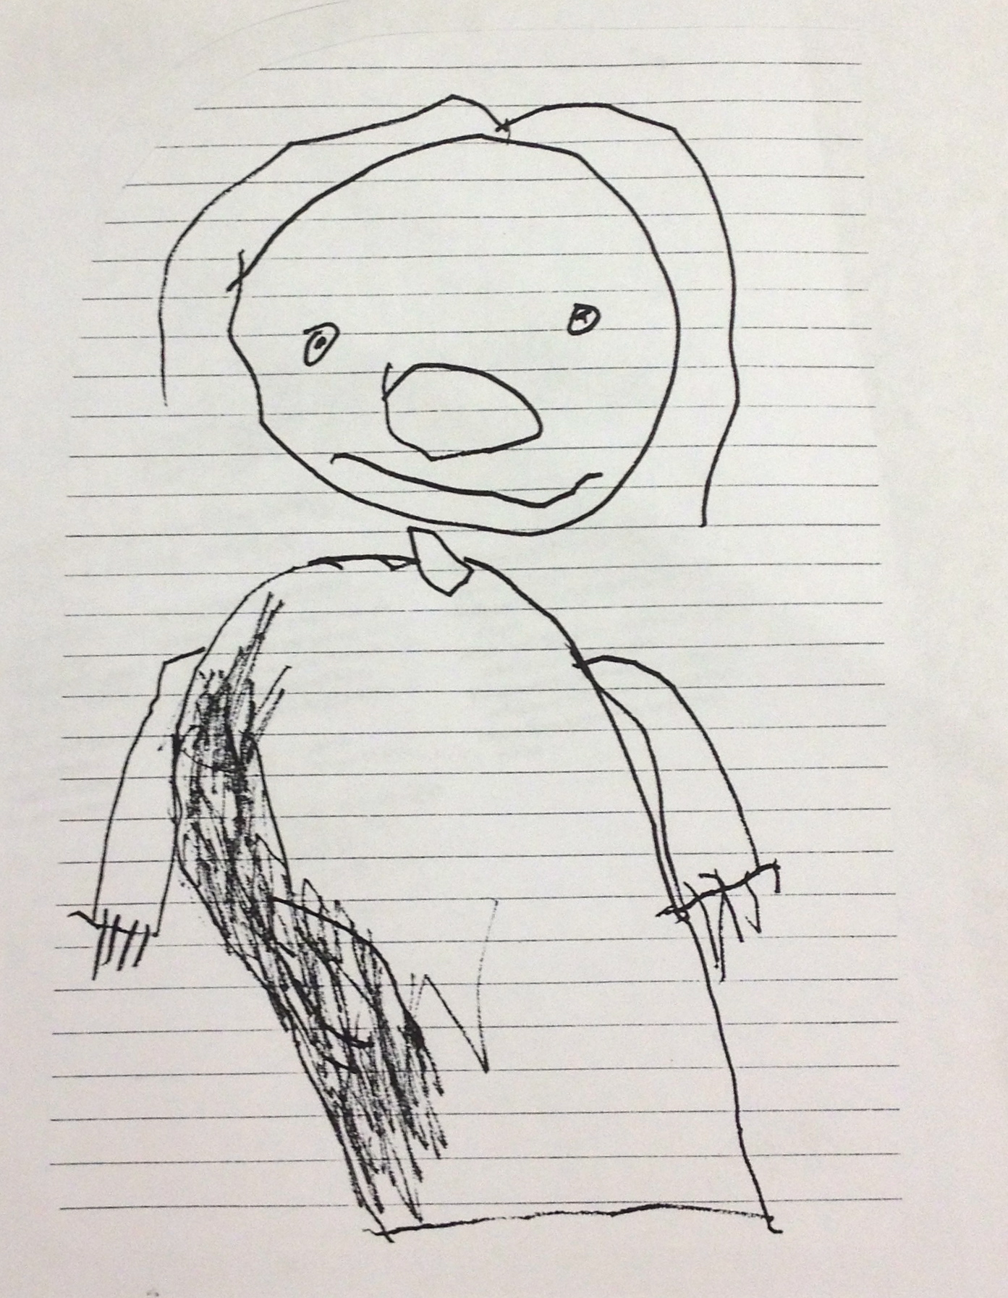
Figure 1. An example of a child's drawing in the Preschematic Stage
personal reflection. After working with children and watching them draw and create works of art, I now have a new outlook on what their drawings mean to their development. Before researching this topic I had never really given much thought to a child’s scribbles or irrational lines on a piece of paper. As a child I remember going through the different stages of art. I remember the first time I realized that I was able to actually draw a person or an animal and it really look like the subject I was drawing. I also remember when I realized the revolutionary idea of coloring within the lines or coloring the characters in my book the same color that they actually are. I never turned to art as a serious talent of mine because I never saw it as something that you could work on to get better, I thought of it with a “you either have or you don’t” mentality. The Mary Erickson and Barnard Young (1996) article titled “What Every Educator Should (But Maybe Doesn’t Know)” made a good point that art isn’t taught like math where students have “mastered these (math) skills not necessarily because of any interest or special natural ability but because they’ve had systematic instruction by trained teacher for most every year” (p. 38-39). After reading that article, I wondered if art really was an acquired talent or something you were born with in the first place. I don’t consider myself as an artist because my drawing skills are so limited. I am, however, able to conceptualize much better than a 1st grader draw can draw an object that looks more realistic to the actual subject. After seeing the stages of a drawing, I wonder if I had worked on my artistic ability I could have developed into a better artist. As a teacher, I need to use this information of where my kids are in the developmental stage of art to correctly guide my student’s in their artistic ability. I also need to analyze my students drawings to make sure their stage of ability matches up with how old they really are. The drawing that I am going to analyze is definitely in a specific stage of artist development, and if the child keeps at it with the right instruction and encouragement he has the potential to maybe a great artist one day.
Conclusion
As a teacher, I need to encourage my students to, within the ability that they have to create art, to develop their own way of creating it. I need to be aware of what stage they are in their artistic ability, so I do not ask too much of them and know they are on track with their age group and cognitive development. I ultimately, want my students to become their own artists and go through the stages organically, so they can become the artists they were born to be. Trey will need to work on the proportions and the realistic qualities of his drawing, but I need to, as the teacher, encourage him to out of his own imagination create how he thinks he should create his artwork. In the article “Learning to draw: nurturing the natural” the author states that “children’s drawings were ruled by unconscious innate ‘laws of forms’—that children follow inborn universal rules as they learn to use the language of drawing” (Maryland Board of Education of Baltimore County, 1974, p. 59). The children need to learn to draw and do these things on their own so their natural organic ability can come out. I will integrate an art project into my lesson plans to give my students the opportunity to use and further develop their artistic abilities.

References
Brittain, W. L., & Lowenfeld, V. (1970). Creative and mental growth. New York, NY: Macmillan.
Erickson, M., & Young, B. (1996). What every educator should (but maybe doesn’t) know.
School Arts, 96(2), 40-42.
Kellogg, R. (1970). Analyzing children’s art. Palo Alto, CA: National.
Maryland Board of Education of Baltimore County. (1974). Beginning stages of visual expression of young children. In Art Experience, Development of Visual Perception,1-4.

